Computer AppliCAtion prACtiCAls

DAy 4 prACtiCAl no 4:

**Create a document in MS Word that explains how to create and save a new document. Include simple instructions aimed at complete beginners**

Creating and Saving a New Document in Microsoft Word

*Step 1: Opening Microsoft Word*

* Click on the Microsoft Word icon on your computer to open the program.

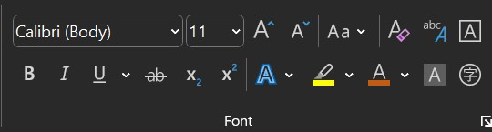

*Step 2: Creating a New Document*

* Click on the "File" tab in the top left corner of the screen.
* Select "New" from the drop-down menu.
* Choose "Blank Document" from the template options.

*Step 3: Typing Your Document*

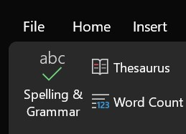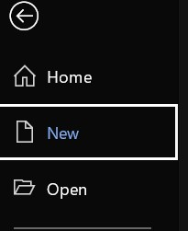

* Start typing your document in the blank page that appears.
* Use the tools on the toolbar to format your text, such as font, size, and color.

*Step 4: Saving Your Document*

* Click on the "File" tab again.
* Select "Save As" from the drop-down menu.
* Choose a location on your computer to save the document (e.g. Download or Documents folder).
* Type a name for your document in the "File name" field.
* Click "Save" to save your document.

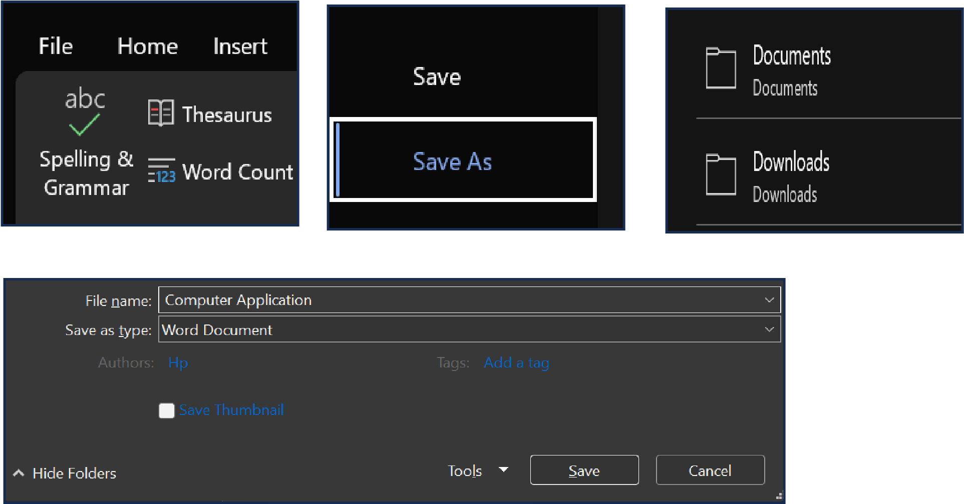

That's it! You have now created and saved a new document in Microsoft Word.